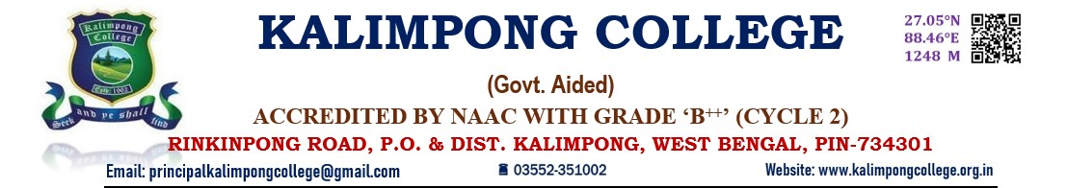

REPORT ON DIAMOND JUBILEE ACADEMIC TALK

On the occasion of the Diamond Jubilee Celebration of Kalimpong College, the IQAC and Diamond Jubilee Celebration Committee organised an academic talk on 9th November, 2022 at the College Hall.Dr. Rajendra P. Dhakal, Principal, Kalimpong College presented the Academic Talk on**‘Diaspora, Identity and Political Culture: A Case of Nepali Speaking Indian Gorkhas’**. The talk was attended by the teachers, and students of 5th Semester Honours and M.A. Political Science of Kalimpong College.

At the outset, the Principal stated that he was not an expert on the subject, but that he would try and convey his ideas in the simplest possible way to the diverse audience present in the talk. He went on to explain the questions ‘Who are we? Gorkhas or Nepalis?’ Preferring to use both terms synonymously, he went on to talk about how history has been misread and miscommunicated by people who were not exactly historians. He explained the term ‘Diaspora’ and how it applies to the sense of belongingness to a people. He went on to explain his ideas regarding the different case of the Gorkhas in terms of history, geography, borders, migrations and racial assimilations. He also expressed how both the Central Government and the State Government have had a problem with the identity of the Gorkhas and have misunderstood them. He ended with the need of the Gorkhas themselves to feel comfortable and assured about their Indian identity and their similarity with all other Indian bretheren.

The talk was followed by questions Raised by Dr. Gauranga Das( Department of Philosophy), Mr. D.D. Rai(Department of Geography) and Dr. Binita Rizal(Dr. Binita Rizal) to which Dr. R.P. Dhakal responded with satisfactory answers, and the repeated emphasis on Nepali Gorkhas to come out of their own ignorance, political anxiety and insecurity and change their own ideas of identity and representation.

