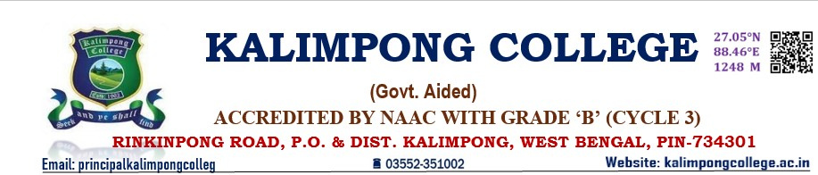

7.2 Best Practices

|  |  |  |
| --- | --- | --- |
| Department | Details of the Best Practices | Year/Date of commencement |
| History | Students are encouraged to participate in various co-curricular and cultural activities in various events in order to enhance their confidence level and to develop the personality of the students. | 2015 |
| Students encouraged to make summary and presentation of lesson in the classroom and also encouraged to practice teaching with the junior classes. | 2021 |
| Motivation of students through awards and prizes on the basis of their performances in the departmental seminars and other activities. | 2022 |
| Mentor – mentee activities | 2022 |
| Donation of personal books by the faculty members to the poor students. | 2015 |
| Faculty members have paid admission fee for the poor students. | 2023 |
| Faculty members provide academic, psychological and career counselling to the students. | 2017 |
| Excursions | 2006 |
| Philosophy | Encouraging to the students to increase their interest to go out to have the expose and high quality knowledge and interaction between students and faculty | 2022 |
| Committed to develop reciprocity and cooperation among students and build relationships between teachers and students that promote a safe and positive environment in which students are responsible, self-motivated and self-evaluating. | 2022 |
|  | Encouraging active learning with advanced teaching tools | 2023 |
| Arranging round table discussion end of the every week | 2023 |
| Geography | Departmental Library | 2006 |
| Lost and Found Section | 2008 |
| Special Lectures | - |
| Students Seminars | - |
| Sociology | Students are encouraged to participate in various co-curricular and cultural activities in various events in order to enhance their confidence level and to develop the personality of the students. | 2015 |
| Mentor – mentee activities | 2022 |
| Botany | Maintenance of Medicinal plant garden & Compost pit |  |
| Zoology | Laboratory Exposition Programme | 10.11.2022 |

