

Name of the schools Invited during Diamond Jubilee Celebration for Science Exposition, 2022

Date: 10/11/2022

|  |  |  |
| --- | --- | --- |
| **Sl. No.** | **Name of the school invited** | **Name of the school participated** |
| 1 | Indo-Tibetan Higher Secondary School | No |
| 2 | SUMI | Yes |
| 3 | Kalimpong Girl’s Higher Secondary School | Yes |
| 4 | Pranami Balika Vidya Mandir | Yes |
| 5 | Kumudini Homes | Yes |
| 6 | Dr. Graham’s Home | Yes |
| 7 | St. Augustine | No |
| 8 | St. Philomena | No |
| 9 | St. Joseph’s Convent | No |
| 10 | Rock Valle Academy | Yes |
| 11 | Springdale Academy | No |
| 12 | Brindavan Academy | Yes |
| 13 | Gangotri Higher Secondary School | No |
| 14 | Kendriya Vidyalaya | No |
| 15 | Kamal Jyoti Vidya Peeth | Yes |
| 16 | Saptashree Gyanpeeth | Yes |
| 17 | Jubilee Higher Secondary School | No |
| 18 |  |  |

**Report on Science Exposition, 2022**

On the auspicious occasion of Diamond Jubilee Celebration, Kalimpong College organised Science Exposition, 2022 on 10/11/2022, where Eighteen Schools (List attached), from Kalimpong District, having Higher Secondary Courses in Arts, Science and Commerce were invited. In this occasion the entire Laboratory based Departments (*viz* Botany, Chemistry, Geography, Mathematics, Physics and Zoology) of this College were involved. Each departments displayed their respective equipments, instruments, models etc for the visitor students. The volunteers from respective departments explained lucidly about the displayed equipments, instruments, models etc to all the students of different Schools. Most of the Teaching and Non-teaching staffs of our College also visited and gave their feedback. In total nine Schools took active participation. Later they were provided packet lunch, water bottle, juice etc before their departure. The programme started at 10:00 am sharp and closed at 4:00 pm. The Programme was a grand success and the organising committee acknowledge the necessary helps extended by all the faculty members of different departments.

Date: 11/11/2022

Place: Kalimpong College Convenor,

Science Exposition Committee

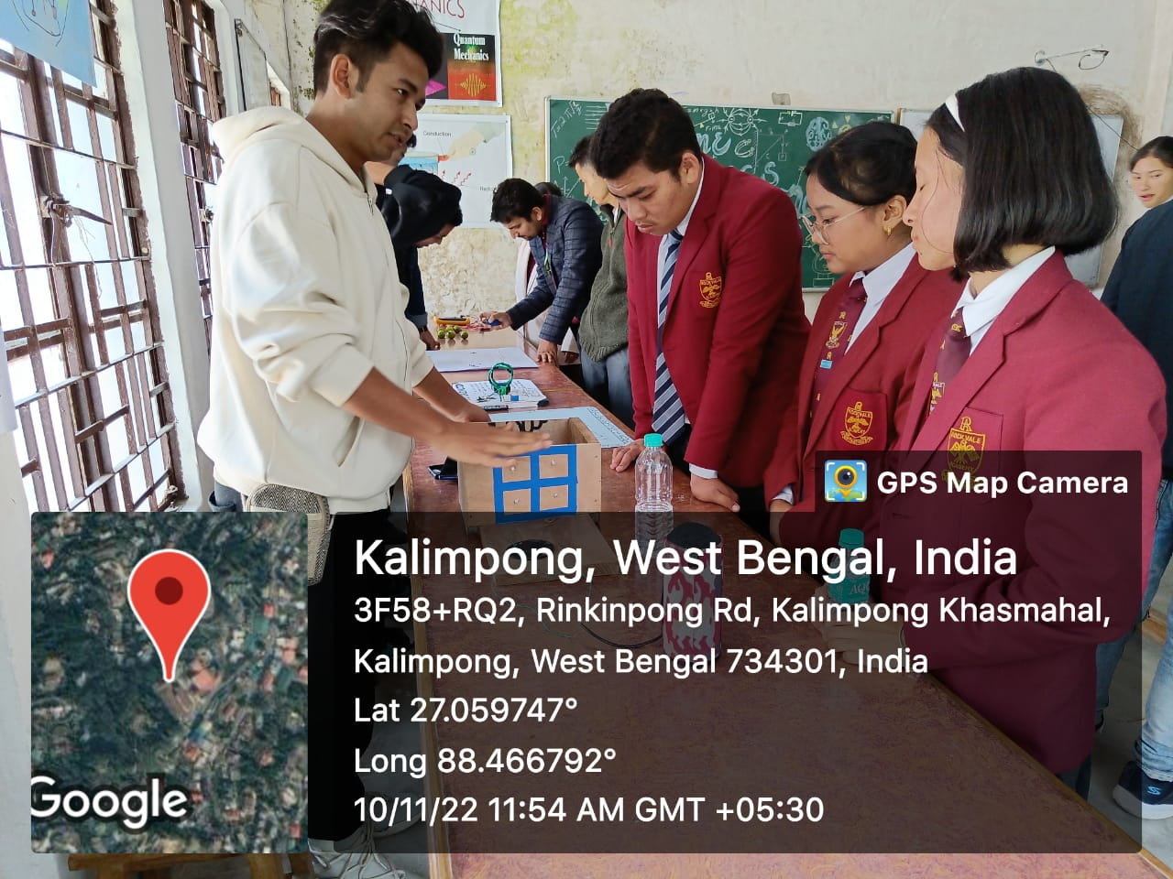 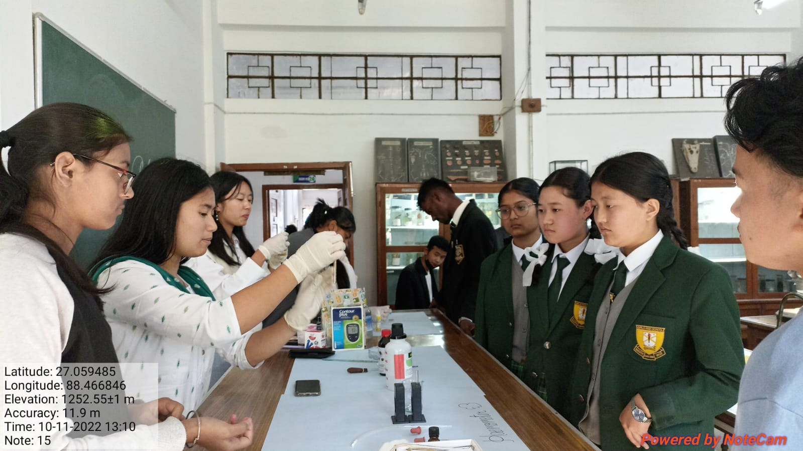

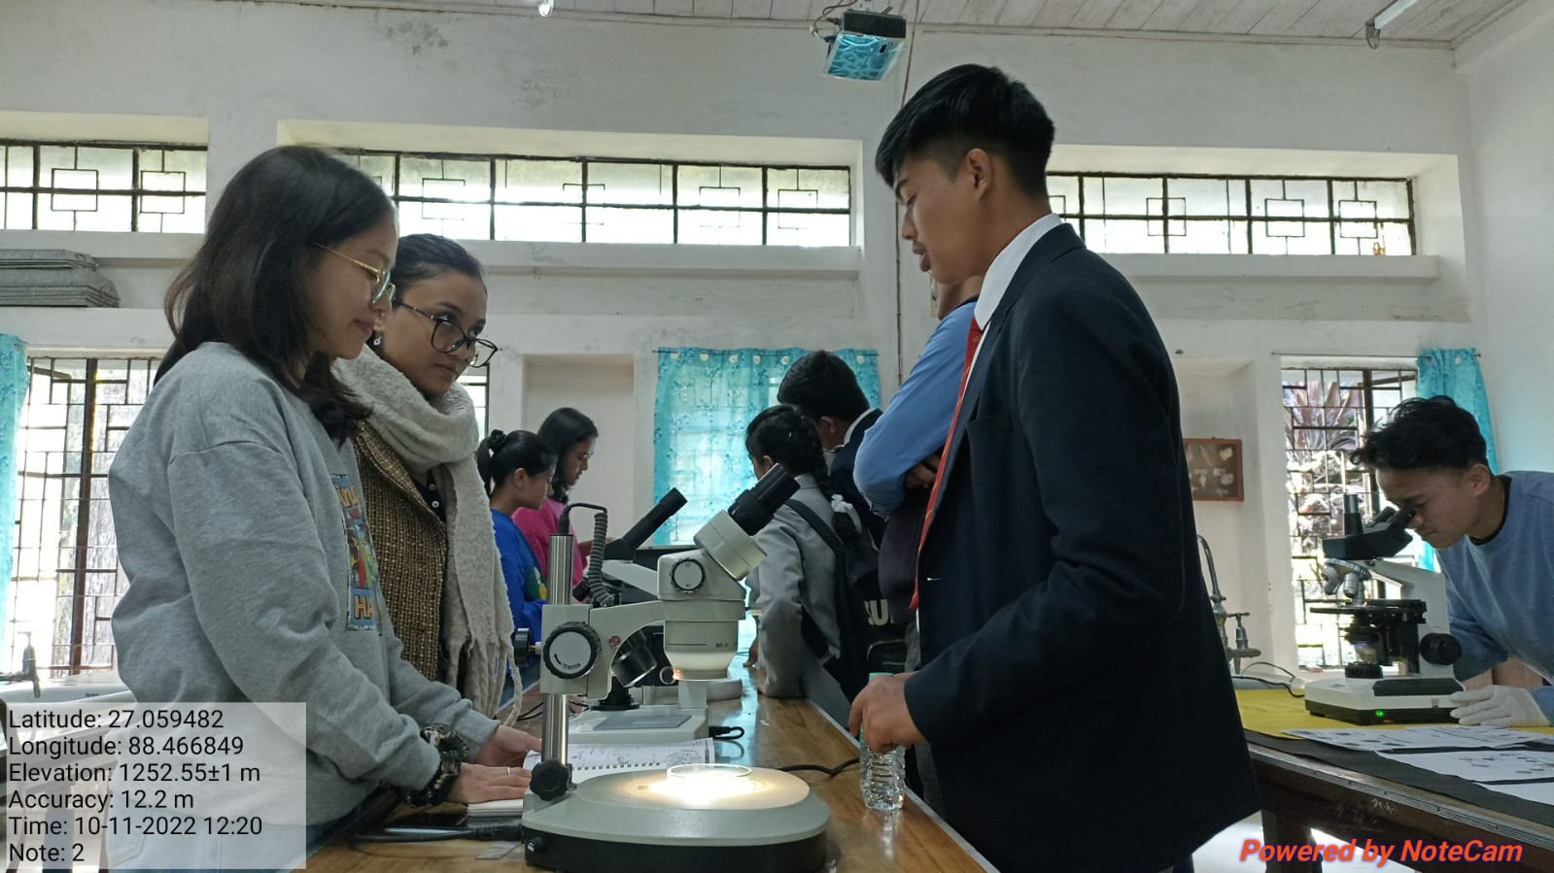 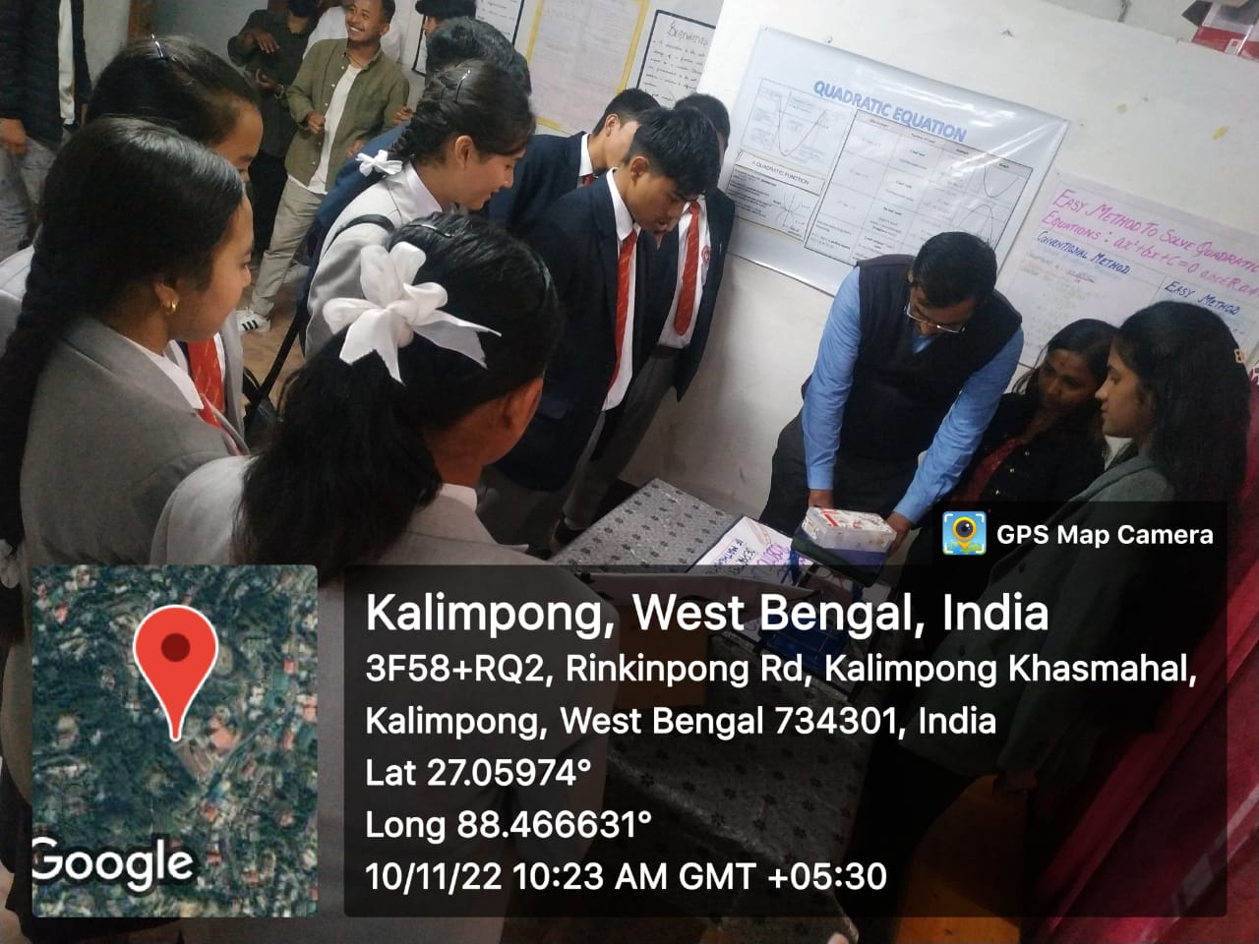

DIAMOND JUBILEE CELEBRATIONCELEB, 2022

Laboratory Exposition Programme

Department of Geography

Kalimpong College

Date- 10.11.2022, Venue- Geography Laboratory

**Introduction**

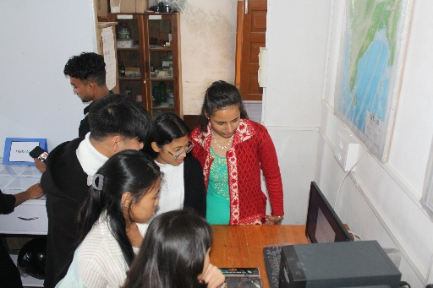 It has been observed that very few students of the hill areas of Darjeeling opt for science subjects. All the students with science combination in Higher Secondary or equivalent examinations do not pursue Science stream in the Undergraduate level. Majority of the students have been found to develop, right from their secondary level a perception that science subjects are tough and only brilliant students should go for it, which is not true.

Aim

To make science a popular discipline among the students of the Hills of Darjeeling right from the secondary and +2 level and thereby pave the way for them for the advanced fundamental scientific research in future.

Objective

To facilitate hands-on experience of all the laboratory equipments, apparatuses, specimens, Topographical Sheets, gadgets, aerial photographs, Satellite Imageries, GIS software, GPS Receiver etc.

**Details of Exhibits in the Exposure Program**

|  |  |  |
| --- | --- | --- |
| Sl.no. | Type of exhibits |  |
| 1 | Surveying and Levelling | a) Chain Survey Set  b) Prismatic Compass Set  c) Plane Table Set  d) Dumpy Level Set  e) Transit Theodolite Set |
| 2 | Image Interpretation | a) Mirror Stereoscope  b) Pocket Stereoscope  c) Aerial Photographs  d) Satellite Imagery |
| 3 | Meteorological Instruments | a) Simon’s Rain Gauge  b) Fortin’s Barometer  c) Maximum and Minimum  Thermometers  d) Dry Bulb and Wet Bulb  Thermometers |
| 4 | Rocks and Minerals | Set of Rocks and Minerals |
| 5 | Global Positioning System | GPS Receiver |
| 6 | Cartographic Instruments | a) Amslar Polar Planimeter  b) b) Pantograph/ Pantagraph |
| 7 | GIS Software | QGIS( Quantum Geographic Information System |
| 8 | Landscape Study (Relief and associated cultural features) | a) Topographical Maps |
| 9 | Maps | b) Physical maps  c) Political Maps |
| 10 | Pens, Templates and Drawing Instruments | Isograph pens, Templates and all types of drawing instruments |

**Name of Schools that attended the programme:**

|  |  |  |  |
| --- | --- | --- | --- |
| Sl.no. | Name of school | Address of the school | No.of visitors |
| 1 | Kalimpong Jubilee Higher Secondary School | Dr. B.L. Dixit Road, Kalimpong | 3 students+1 teacher |
| 2 | Saptashri Gyanpeeth | Taxari Road, Chhota Bhalukhop, Kaliompong | 5students+1 teacher |
| 3 | Scottish Universities Mission  Institution (SUMI) | Mission Compound, 10th Mile , Kalimpong | 3 students+1 teacher |
| 4 | Kumudini Homes Higher Secondary School | H.L.Dixit Road,Bong Busty, Kalimpong | 3 students+1 teacher |
| 5 | Sai Institute of Education and Research | East Main Road, Kalimpong. | 3 students+1 teacher |
| 6 | Rockvale Academy | Rishi Road, Mongbol Busty, Kalimpong | 3 students+1 teacher |
| 7 | Students and faculty members of the College | Ringkingpong Road, Kalimpong. | Majority of the faculty members and students visited the programme. |

**Significance of the program:**

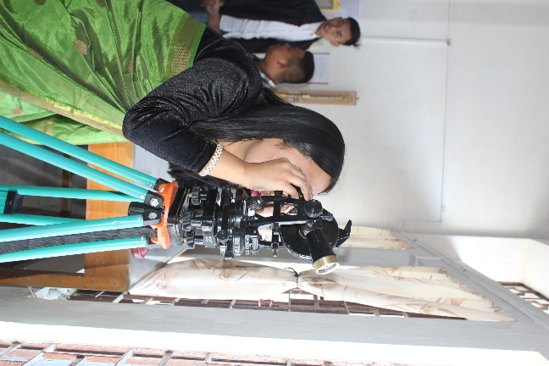 The program was entirely organized and conducted by the students of the department. The College and the department provided necessary guidance and logistic support. So host as well as the guest students were immensely benefitted by the programme.

**Feedback:**

All the visitors appreciated the programme very much. None of the visitors made any serious remarks in the feedback section of the form. Majority of the visitors suggested that the college may organize such program every year.

**Conclusion:**

As both the Host and the Guest students were greatly benefitted by the program, the program was a great success. The aim and the objective of the program was greatly served and hence it is highly desirable that the college organize such program every year.

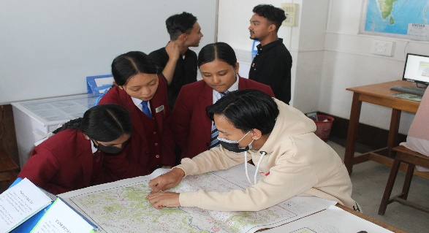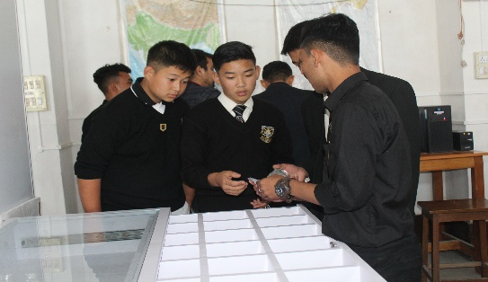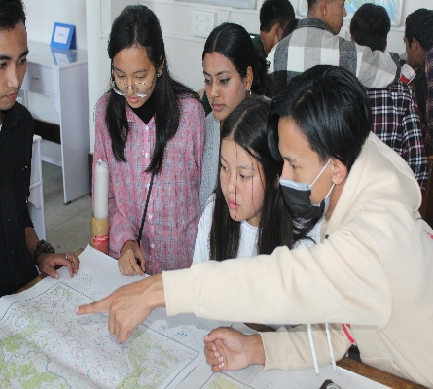

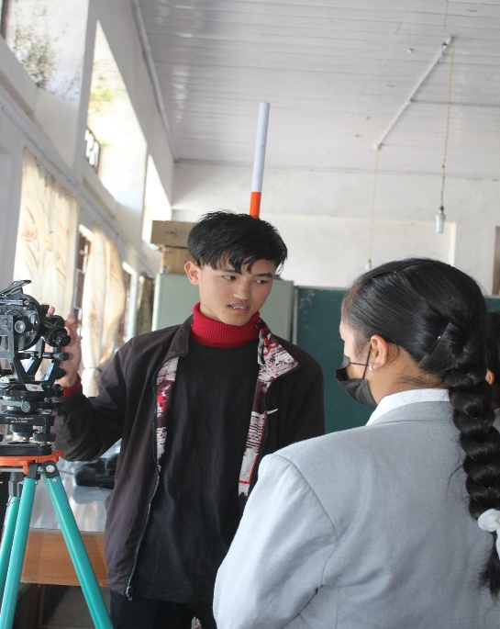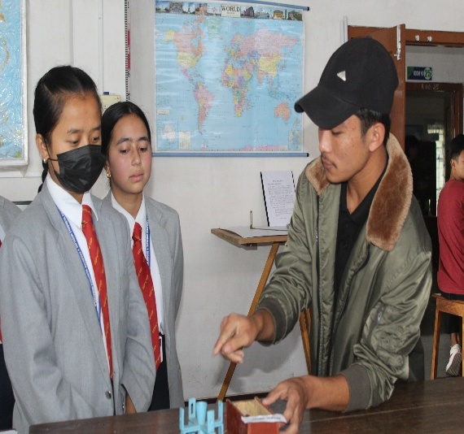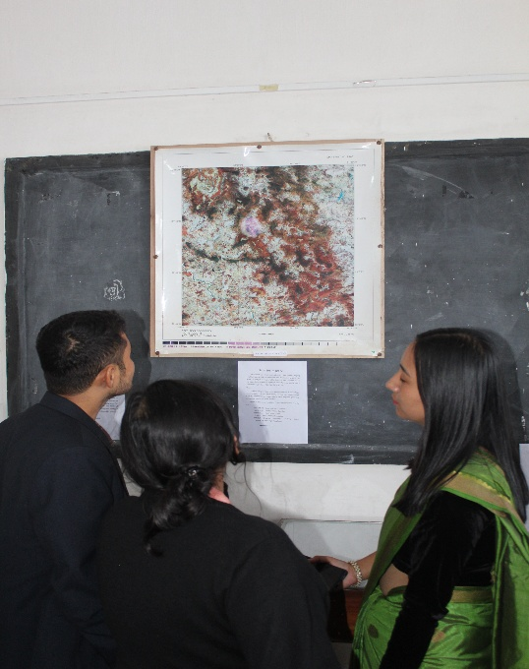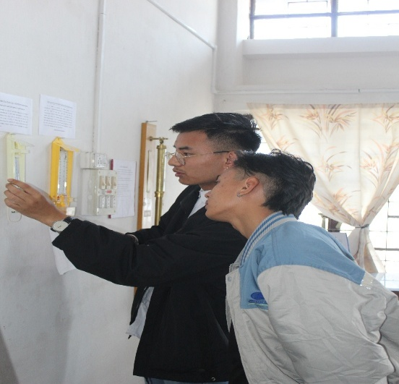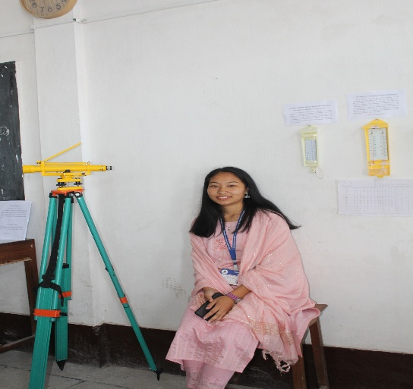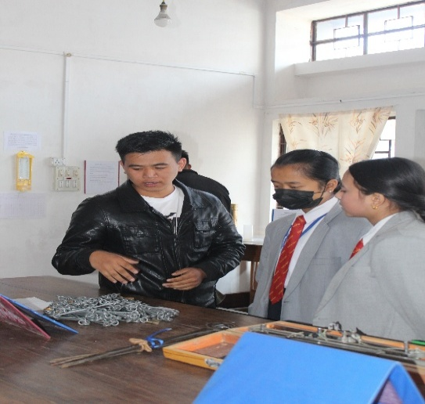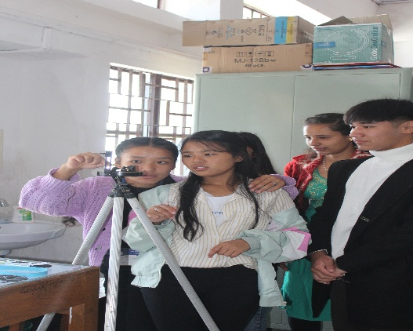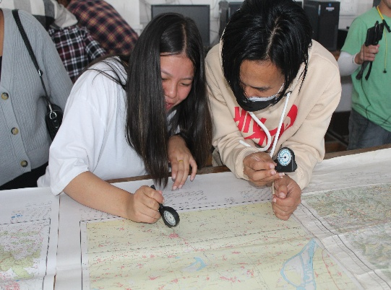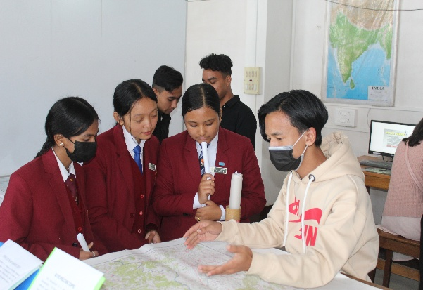

**PHYSICS LAB EXPOSITION 2022: A REPORT**

A lab exposition was organized by the college on 10/11/2022 as a part of College Diamond Jubilee celebration. The aim was to give an exposure to the school students of the lab facilities our institution provides and give a virtual demonstration of instruments and theories that are only known to them in books. The Departments put up a great display of all the instruments and working models that fascinated the youngsters and led the expansion of scientific horizon. A brief report of exhibition organized by Physics Department is recorded here.

1. **Instruments displayed**

|  |  |
| --- | --- |
| **List of Instruments** | **Objective** |
| Spectrometer | To show the dispersion of light through prism and formation of VIBGYOR. |
| Newtons Ring | To show thin film interference pattern. |
| Travelling microscope, screw gauge,  spherometer, slide calipers, balanced spring | To show the measuring devices of various scales. |
| B-H loop | To show the hysteresis loop of a ferromagnetic material and calculated energy loss. |
| Measurement of moment of inertia of flywheel | Introduction to the concept of moment of inertia and its measurement. |
| Young’s modulus of wire by optical lever | To observe the minute extension occurring in the wire when weight is added to it and to determine the change with the help of telescope  and mirror, scale arrangement. |
| Coupled pendulum | To observe the motion that occurs in the pendulum that are tied together with a spring. Show the time period of oscillation, energy  transfer, formation of beats. |
| Bar pendulum | To show how oscillation of a bar pendulum about its center of  gravity can be used to calculated the value of acceleration due to gravity(g) and radius of gyration. |
| Motion of a Spring | To show the Simple Harmonic motion of a spring with increasing weight and measurement of time period to determine the value of g and spring constant. |
| Logic gates | To show working of OR, AND, NOT gates. |
| Wheatstone bridge | Introduction to the basic principle of Wheatstone bridge, determination of null point and value of unknown resistance. |
| Meter bridge, potentiometer, electrical components | To acquaint students to use of resistances, ammeter, voltmeter, galvanometer. Use of potentiometer to measure potential and internal cell resistance. The application of Wheatstone bridge in the meter bridge used to determine the unknown resistance. |
| Poster presentation | Poster demonstration of GPS system, Newtons Law, Spherical Mirror, Li-Fi, Electromagnetic induction, Solenoid, Mutual Inductance. |

1. **Models Displayed**

|  |  |  |  |
| --- | --- | --- | --- |
| **Model** | **Observation** | **Working Principle** | **Objective** |
| Li-Fi  (Light Fidelity) | Music from mobile was transferred to the speaker with the help of led lights and solar panel. | When a device (mobile audio) sends data in the form of light it travels with the speed of light and the receiver (solar panel) connects the data with the speaker. Hence data is transferred from one device to another with help of light | Li-Fi was made possible solely by the efforts of our  students. It is considered to be the future for wireless and speed transfer of data and internet exploration. This was the main attraction of the exhibition and it  amazed everyone. |
| Electromagnetic Induction | Two coils are taken and current is made to flow in one of the coils. LED light is connected with the other coil and when brought in the vicinity of  the first coil the light glows. | When current is made to flow in the primary coil it induces current in the adjacent secondary coil via the phenomenon of mutual inductance making the light glow. This phenomenon is known as electromagnetic induction | Virtual understanding of electromagnetic induction and mutual induction as this is the principle used in power transformers. |
| Lemon Cell | When 5 to 6 lemons are connected using iron and copper as the electrodes it produces a potential of 3V making a weak LED glow. | It is phenomenon of electrolysis, that is the basis of electrical batteries. Here iron and copper are used as two electrodes and electrolyte is the lemon juice inside the lemon that is acidic in nature. When such cells are connected in series it can produce  feeble current. | To demonstrate the phenomenon of  electrolysis and working of batteries and also to make them aware how physics can be applicable in  simple things. |
| Electromagnetism | 1. Current is made to flow in the coil wounded as solenoid can produce deflection in the magnetic needle. The direction of deflection changes when the polarity is changed. 2. Current is made to flow in coil closely wounded in the iron core, it can attract magnetic materials. | Both are due to the phenomena of electromagnetism. Moving current produces magnetic field around it making magnetic needle deflect. The strength of the magnetic field can be increased by increasing the number of turnings and when the strength of the current is increased so that it can attract magnetic materials. The magnetism lasts as along as the current flows in the coil. | The principle of electromagnetism has a wide application in designing various electrical equipment and is also used to produce magnets of huge strength to lift heavy materials. Therefore, an effort was made to give a  virtual demonstration of it. |

1. **Visitor’s Response**

|  |  |  |
| --- | --- | --- |
| **Name of School/**  **Other Departments** | **Number of**  **visitors** | **Overall Comments** |
| Rockvale Academy | 7 | * The exposition helped them to clear few basic concepts of Physics. * Was astonished to see lemon producing light, dispersion of light through prism, electromagnetism and induction. * Was impressed by the decorum of the lab and the instruments that were displayed. * Was content by the demonstrations delivered by the students that helped them understand the underlying concepts. * Li-Fi was a new thing to see and most appreciated model of the exhibition. |
| Saptashri Gyanpeeth | 7 |
| S.U.M. I | 5 |
| Sai Institute of Education and  Research | 7 |
| Girl’s Higher Secondary  School | 7 |
| Pranami Balika Bidhiya  Mandir | 7 |
| Dr. Graham’s Homes | 4 |
| Dept. Geography | 3 |
| Dept. Zoology | 4 |
| Dept. Political Science | 5 |
| Dept. Mathematics | 10 |
| College Faculties | 30 |

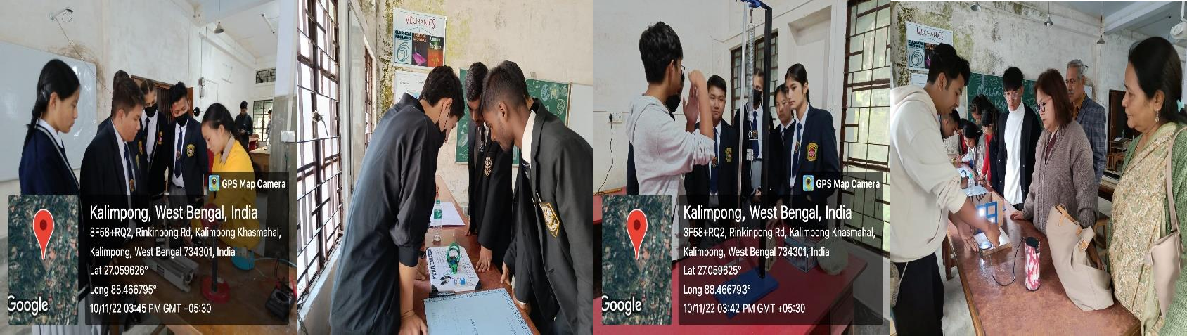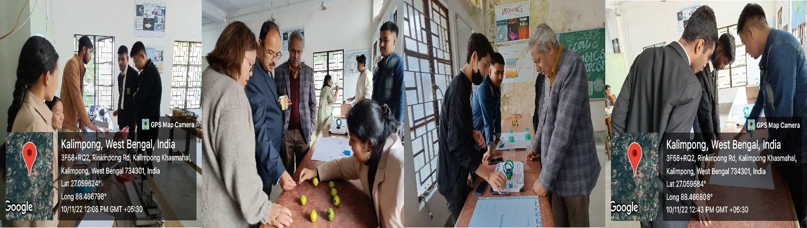

**Few stills from Diamond Jubilee Kalimpong College: Physics Lab exposition, 10/11/2022.**



