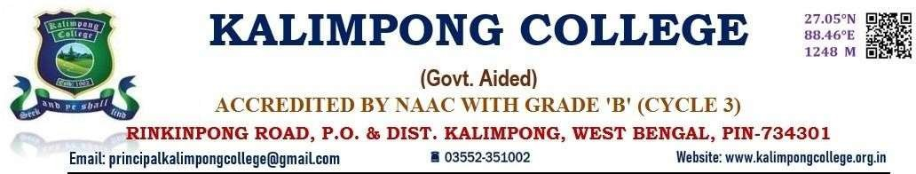

**DIAMOND JUBILEE CELEBRATION 2022**

**FOOD FEST**

**KALIMPONG COLLEGE**

**DATE: 10. 11. 2022**

On the eve of Diamond Jubilee different departments of the Kalimpong College undertook the initiative to organize the Food Fest in the campus premises to bring together the students, faculty and staff to celebrate the diversity of cuisines and cultures represented in campus. The event aimed to promote unity, creativity and community. More than hundreds of student participated in the food fest. Students showcased a wide range of cuisines including Indian, Chinese and Continental. More than 10 stalls were set up offering the diverse array of dishes, from traditional favorites to innovative fusion cuisines. Over 100 of students participated in the event either by setting up food stalls, cooking or volunteering. The event attracted large number of attendees including students, faculty and staff.

**Feedback from the attendees**:

* Attendees praised the variety and quality of food available
* Attendees commended the mentors for their efforts in managing the event
* The event showcased the talents and culinary skills of the college students
* It highlighted the entrepreneurial spirit of the college student
* It is one of the best events to promote unity and integrity amongst the community.

The Food Fest was a resounding success bringing together the college community to celebrate diversity, creativity and cultural exchange.

