**Fostering Knowledge and Creativity: Library Week 2024**

**Ms. Pauline Ahoy**

**Convener, Library Committee**

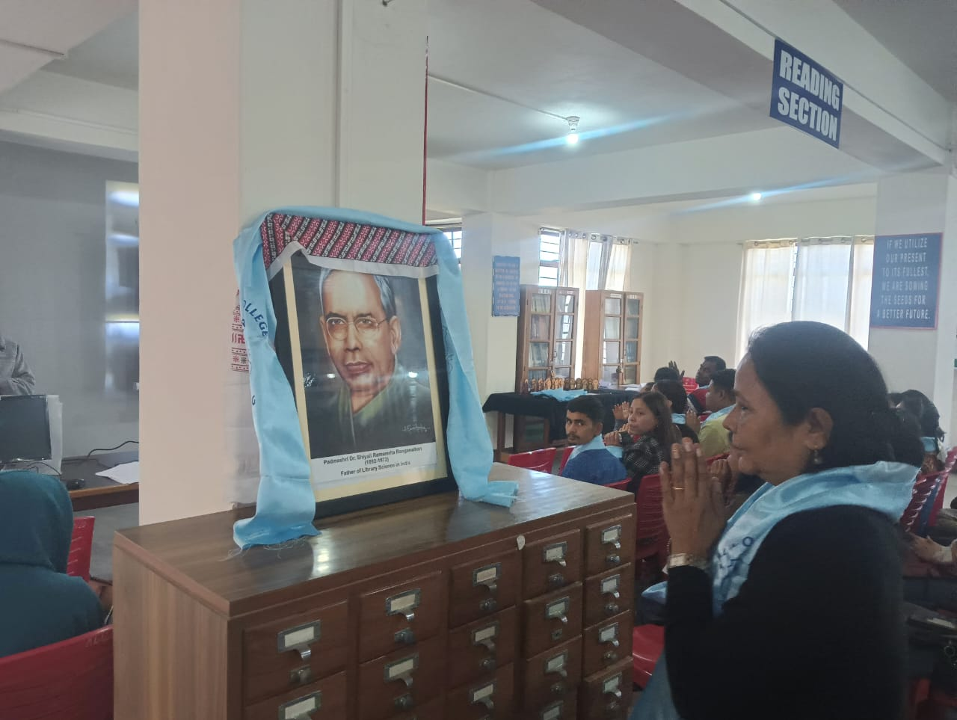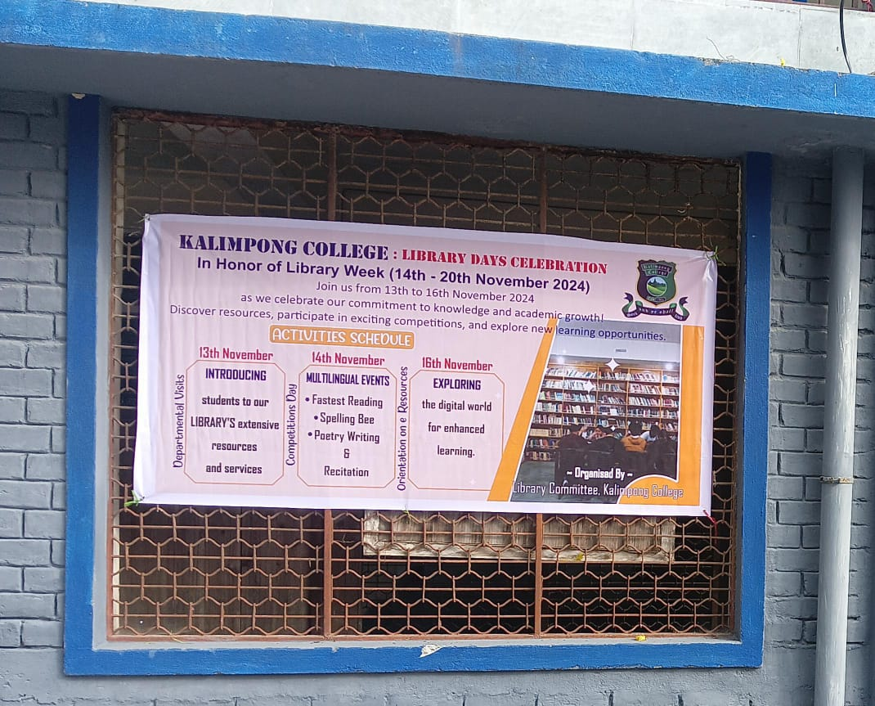On the 13th and 14th of November 2024, the Library Committee of Kalimpong College organized a grand programme to promote dedicated knowledge-sharing and academic growth on the auspicious occasion of Library Week.

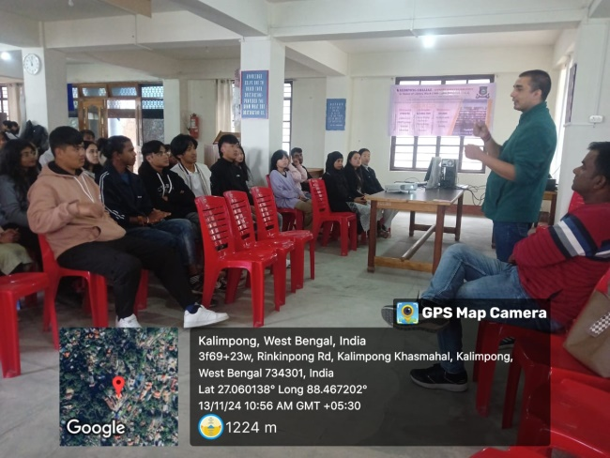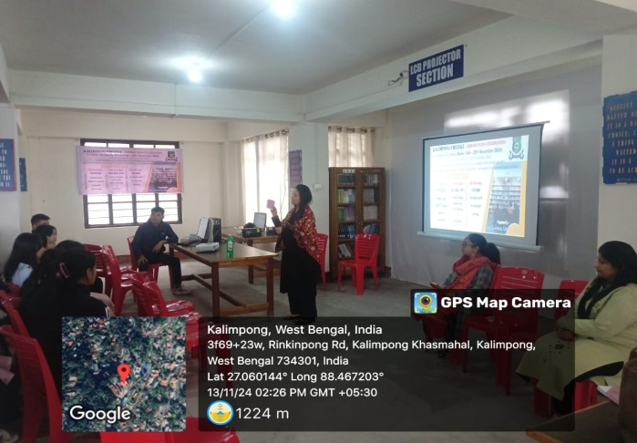On 13th November, students were introduced to the library’s extensive resources and services by Dr. Rekh Mani Sharma, and Mrs. Barsha Chettri along with the library staff members who also participated in the session. Students were oriented to various sections of the library, including the Reference Section, Magazine Archive Section, Textbook Section, and Circulation Section.

Key highlights from the first day of the Library Week celebration included:

1. An introduction to OPAC (Open Public Access Catalog) and its accessibility.
2. Open Educational Resources and Online access to past question papers for students.

On 14th November 2024, multiple events were held, including:

* Spelling bee
* Poetry writing and Recitation
* Fastest Reading

Ms. Anukampa Subba (English), Dr Shova Limbu (Hindi), and Dr. Mamta Lama (Nepali) served as judges for the events in Nepali and English, respectively.

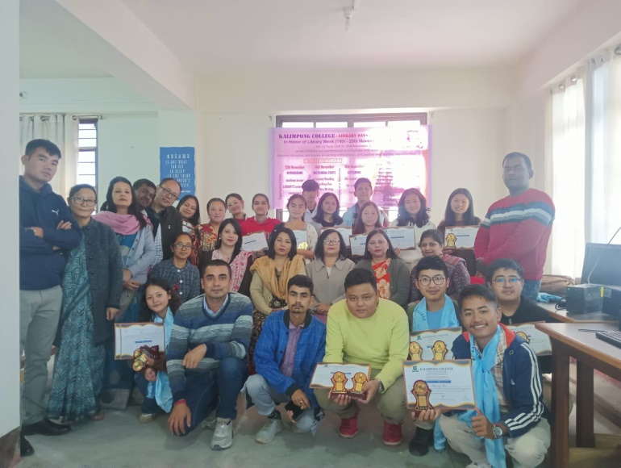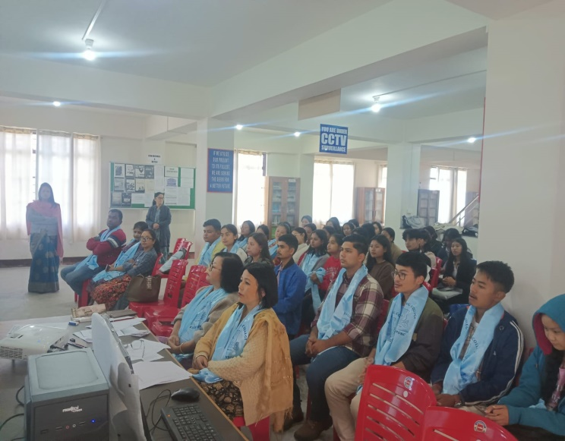

A total of 25 students participated in the competitions.

**Fastest Reading Competition Winners:**

| **English Language** | **Nepali Language** | **Hindi Language** |
| --- | --- | --- |
| 1st: Ms. Trilochana Mukhia | Mr. Shovraj Rai | Mr. Bikash Sharma |
| 2nd: Mr. Nikanor Thapa | Ms. Tshoming Molamo Lepcha | — |
| 3rd: Mr. Tahke Monte Subba | Ms. Choden Bhutia | — |

**Spelling Bee Competition Winners:**

| **English Language** | **Nepali Language** | **Hindi Language** |
| --- | --- | --- |
| 1st: Ms. Eupresia Pradhan | Ms. Priya Tirwa | — |
| 2nd: Ms Chewang Nima Dukpa | Ms. Tshoming Molamo Lepcha | — |
| 3rd: Mr. Nikanor Thapa | - | — |

**In poetry writing and recitation, the following students were the winners:**

| **English** | **Nepali** | **Hindi** |
| --- | --- | --- |
| 1st: Ms. Catherine Tamang | Mr. Bikash Sharma | Mr. Pramod Sharma |
| - | Mr. Richard Rai | — |
| - | Ms. Sirna Rai | — |

The entire programme was hosted by Mr. Gaurav Chetri, a student of the 5th semester. Certificates and mementoes were awarded to the winners by the TIC Madam, Mrs. Devi Chettri. The programme was followed by lunch for the participants, selected judges, and members of the literary committee.

Unfortunately, orientation on E-resources couldn't be provided to the students on account of the upcoming board exams. Exploring the digital world for enhanced learning has been postponed for the next semester.