

**NCC REPORT – 2022-23**

**Activities Report – 2022-23**

The National Cadet Corps (NCC) is an integral part of youth development in India, fostering discipline, leadership, teamwork, and patriotism among young individuals. Kalimpong College NCC, under the guidance of the Indian Army, participated in a series of camps and activities throughout 2023, despite the world still recovering from the impact of the COVID-19 pandemic. The commitment and performance of the cadets in various camps were exceptional, showcasing their dedication and resilience.

***1. Combined Annual Training Camps (CATC)***

In 2023, Kalimpong College NCC cadets actively participated in two Combined Annual Training Camps (CATC):

June CATC (3rd June - 12th June 2023): This camp was held at Kamrang Namchi. The participation included 15 Senior Division (SD) cadets and 8 Senior Wing (SW) cadets. The cadets displayed exemplary discipline and performance throughout the camp.

December CATC (23rd December 2023 - 2nd January 2024): The second CATC was also conducted at Mirik Degree College. This time, 9 SD cadets and 19 SW cadets from Kalimpong College attended the camp, where they engaged in drills, cultural activities, and physical training. The cadets once again demonstrated exceptional teamwork and leadership during the camp.

***2. Republic Day Camp (RDC)***

The Republic Day Camp is one of the most prestigious NCC events in India, with cadets from across the nation competing for the honor of marching in the Republic Day Parade in Delhi. Kalimpong College NCC had three cadets participate in the RDC selection process in 2023:

JUO Prabina Rai and JUO Satish Pokhrel were selected for the RDC drill competition and reached the Namchi Kamrang stage of the selection but could not proceed further.

Cadet Sahil Tirwa represented the college in the cultural section and gave an outstanding performance, making Kalimpong College proud.

***3. All India Camp (Ek Bharat Shreshtha Bharat)***

Kalimpong College NCC had the honor of being allotted a vacancy for the prestigious All India Camp under the "Ek Bharat Shreshtha Bharat" program. Cadet Sahil Tirwa was selected to participate in this camp. However, due to unforeseen issues from the Group Headquarters, the



camp was canceled. Despite this, Cadet Sahil’s selection reflects the high standard of the college’s cadets.

***4. Shooting Camp***

A specialized shooting camp was held at Namchi, Kamrang, for top-performing firing cadets across the region. Kalimpong College was granted one spot in this highly selective camp. Cadet Sahil Lama was chosen to attend the 10-day camp and represented the college with distinction, further enhancing the reputation of Kalimpong College in shooting events.

**Conclusion**

Kalimpong College NCC has continually demonstrated its commitment to excellence in all areas of NCC training and camps. The cadets’ participation in various camps in 2023, from CATC to RDC and shooting, highlights their discipline, leadership, and dedication. The college remains one of the top-performing institutions in the region, and with continued effort and enthusiasm, the cadets are sure to achieve even greater success in the future.

We look forward to more opportunities and successes in the coming days, as Kalimpong College NCC continues to uphold its proud tradition of excellence.

This report not only highlights the events attended by the cadets but also captures their spirit of perseverance and dedication.

-----------------



**NCC Day Celebration Kalimpong College, 2022-23**

**Introduction**

NCC Day is an occasion to celebrate the values of discipline, unity, and patriotism that are central to the National Cadet Corps (NCC). Observed annually on the fourth Sunday of November, NCC Day commemorates the foundation of the NCC in 1948 and highlights the organization’s role in shaping responsible and dedicated citizens. In 2023, Kalimpong College NCC marked the day with great enthusiasm, despite the constraints of ongoing college exams. The celebration was led by Lt. Avijit Mete, Associate NCC Officer (ANO), and was a grand success.

Date: November 26, 2023

Time: 10:00 AM - 2:00 PM

Total Participants: 47 Cadets (Senior Division and Senior Wing)

**Event Summary**

The celebration commenced with the Flag Hoisting Ceremony, followed by the National Anthem and the NCC Song, which filled the cadets with a sense of pride and patriotism. The main program featured a variety of performances and speeches that reflected the spirit of NCC and the values it instills in the youth.

**Program Highlights:**

***1. Flag Hoisting and National Anthem:*** The event began with the ceremonial hoisting of the NCC flag, followed by the National Anthem, which set the tone for the day. The NCC Song was also sung, creating a moment of unity and patriotism among the cadets.

***2. Opening Group Performance by 2nd Year Cadets:*** The second-year cadets put up a vibrant group performance that set the stage for the rest of the program. Their energy and enthusiasm were appreciated by all attendees.

***3. Cake Cutting Ceremony:*** A symbolic and joyous moment, the cake-cutting ceremony marked the celebration of NCC’s achievements and contributions. It was a highlight of the day and brought a sense of unity among the cadets and staff.

***4. Cultural Performances:*** Group Dance by First-Year SW Cadets: The first-year Senior Wing cadets performed a lively and energetic group dance that showcased their enthusiasm and talent.



***Solo Song and Dance Performances:*** The celebration also featured impressive solo performances, with cadets displaying their artistic talents in singing and dancing. These performances added to the festive spirit of the event.

***5. Motivational Speech by Lt. Avijit Mete (ANO):*** One of the key highlights of the event was the motivational speech delivered by Lt. Avijit Mete(). His speech inspired the cadets, emphasizing the importance of discipline, hard work, and teamwork in their personal and professional lives. His words served as a guiding force, encouraging the cadets to strive for excellence in all aspects of life.

**Duration and Organization**

The program lasted for 4 hours, starting at 10:00 AM and concluding at 2:00 PM sharp. Despite the time constraints due to the ongoing college exams, the cadets, under the leadership of Lt. Avijit Mete (ANO), successfully organized and executed the event.

**Report Submission**

All photos and relevant information from the event were promptly submitted to the 5 Bengal Battalion Unit, ensuring proper documentation of the event.

**Conclusion**

The 2023 NCC Day celebration at Kalimpong College was a resounding success. The cadets showcased their dedication to the values of the NCC through their performances and participation. The event not only fostered a sense of unity and pride among the cadets but also inspired them to continue working hard in their pursuit of excellence. The support and guidance from ANO Lt. Avijit Mete were instrumental in making the event a memorable one.

Kalimpong College NCC looks forward to continuing this tradition of celebrating NCC Day with even greater enthusiasm in the future.

This report captures the essence of the NCC Day celebration and is ready for submission to the NCC Unit.

-----------------



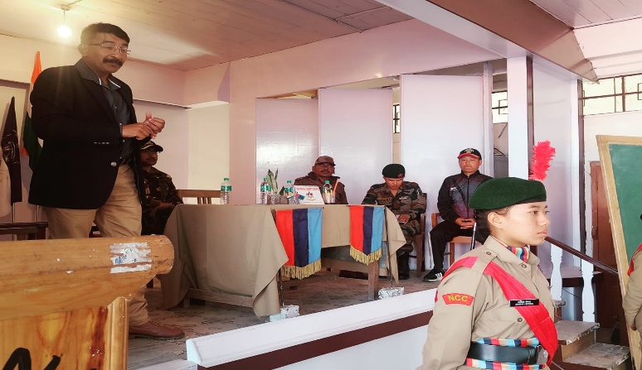PHOTO GALLERY

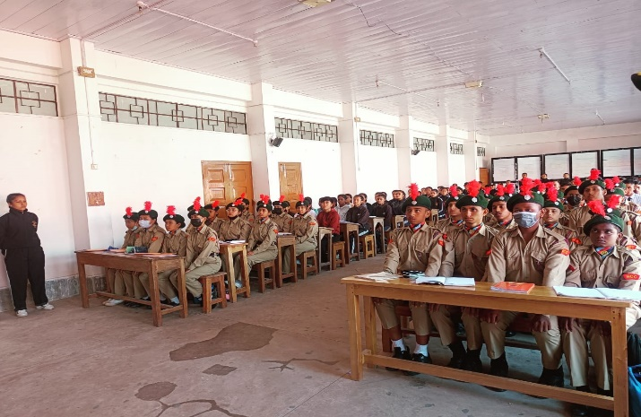

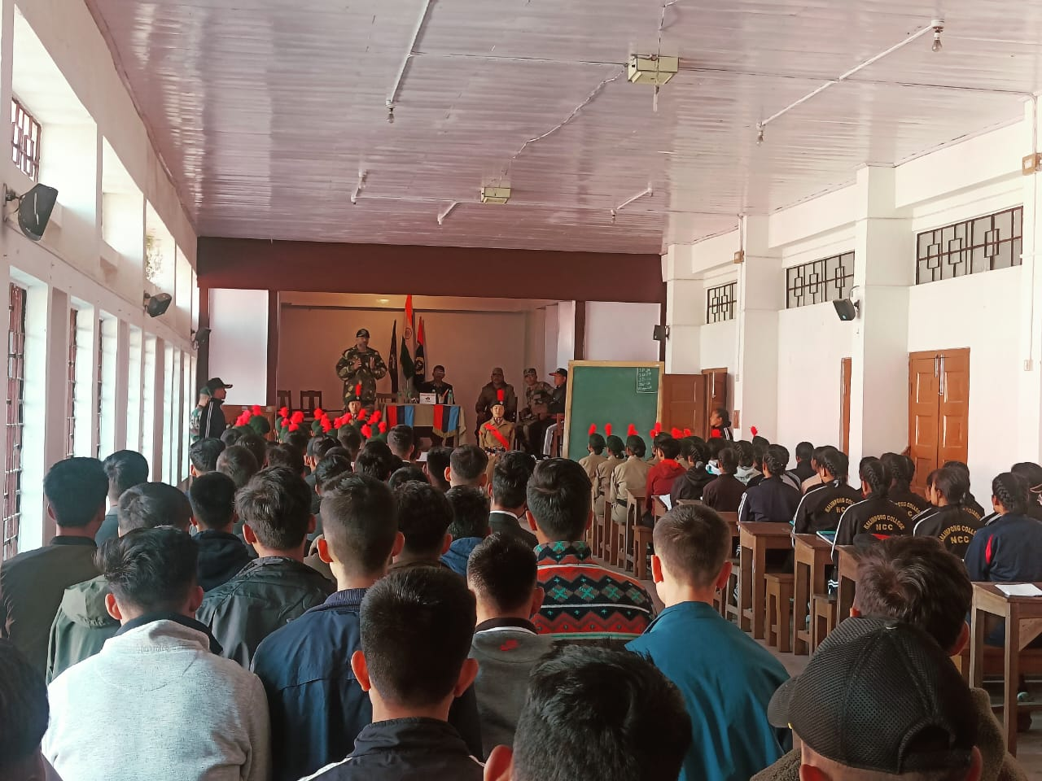



**Independence Day Celebration – 2022-23**

The Independence Day celebration in Kalimpong, known for its rich cultural diversity and picturesque backdrop, was made even more memorable in 2023 with the enthusiastic participation of Kalimpong College NCC cadets. This year's celebration, like every year, was marked by a sense of pride and patriotism, with NCC cadets showcasing their dedication, discipline, and hard work in front of a diverse audience from across India.

Preparation and Participation

The Kalimpong College NCC cadets began preparing for the Independence Day parade 25 days before the event. The practice sessions took place daily from 9:00 AM to 4:00 PM, with a one-hour lunch break in the afternoon. The cadets' dedication during these intense practice sessions was commendable, reflecting their commitment to making the event a success.

Total Cadets Participating: 42 Cadets

Rifle Guards: 8 cadets led by Contingent Commander SUO Rochak Sherpa, with Cadet Simangka Bhujel having the honor of carrying the National Flag.

SW (Senior Wing) Contingent: Commanded by Cadet Radhika Bhujel, assisted by JUO Prabina Rai and Cadet Khushi Gurung.

SD (Senior Division) Troop: Commanded by JUO Satish Pokhrel, with JUO Sewon Limbu, JUO Pema Dorjee Lama, and Cadet Ashish Tiwari as 2ICs (second-in-command).

**Flag Presentation**

The parade included the presentation of three flags, symbolizing the unity and strength of the NCC:

National Flag: Carried by the Rifle Guards, led by Cadet Simangka Bhujel.

College Flag: Carried by the SW Troop, representing Kalimpong College.

NCC Flag: Carried by the SD Troop, symbolizing the values of the National Cadet Corps.

**Event Highlights**

The Independence Day event was held at the Mela Ground, one of Kalimpong's prominent locations, with a large gathering of people, including visitors from different parts of India. The NCC cadets' performance was the highlight of the celebration, as they marched in perfect synchrony, displaying their training and dedication.



The Rifle Guards, under the leadership of SUO Rochak Sherpa, marched with precision and discipline, drawing admiration from the crowd. The SW and SD contingents also performed exceptionally well, with their commanders leading them confidently through the parade.

**Support and Coordination**

The successful execution of the event was made possible through the support of local authorities, who provided funding for the rifle procurement from the NCC Unit and organized packet lunches for the cadets. This collaboration ensured that the cadets were well-prepared and equipped for the celebration.

**Guidance and Leadership**

The entire event was carried out under the able guidance of Lt. Avijit Mete, the Associate NCC Officer (ANO) of Kalimpong College. His leadership and constant motivation played a crucial role in the success of the event, as he guided the cadets through every step of the preparation and performance.

**Conclusion**

The 2023 Independence Day celebration was a great success, thanks to the hard work, discipline, and teamwork of the Kalimpong College NCC cadets. The event not only showcased their dedication to the NCC but also instilled a deep sense of pride and patriotism in all who witnessed it. The cadets learned valuable lessons in leadership, teamwork, and discipline, which will undoubtedly contribute to their growth as responsible citizens and future leaders.

The Kalimpong College NCC unit looks forward to continuing its tradition of excellence in the years to come and hopes to achieve even greater success in future events.

This report reflects the key highlights of the Independence Day celebration and the NCC's role in making it a memorable occasion, ready for submission to the NCC Unit.

-----------------

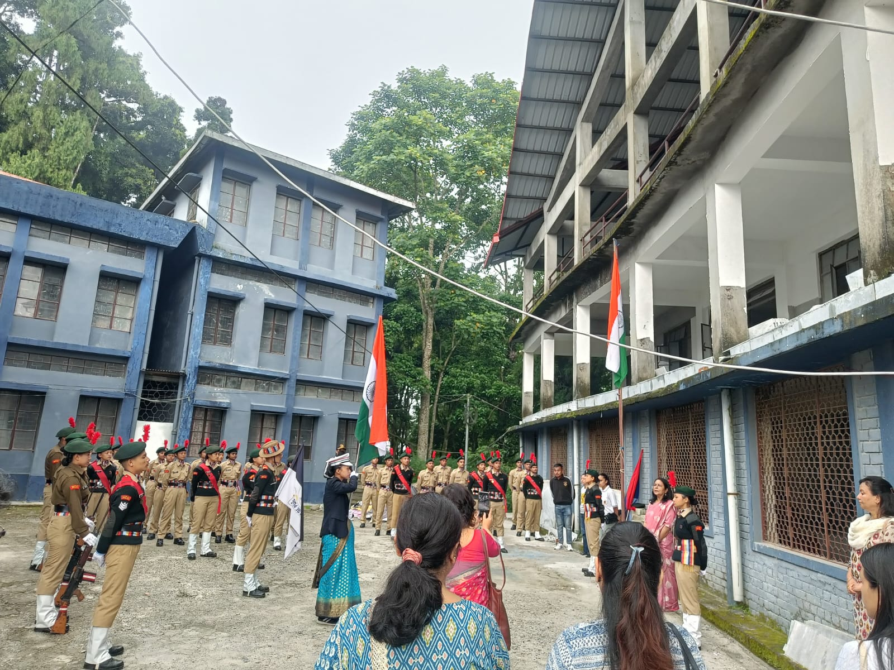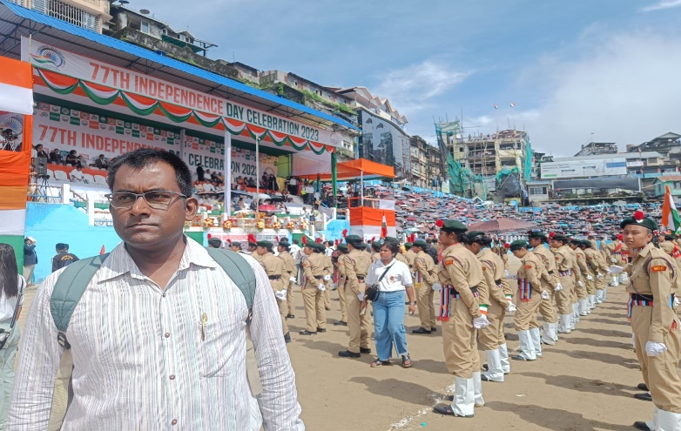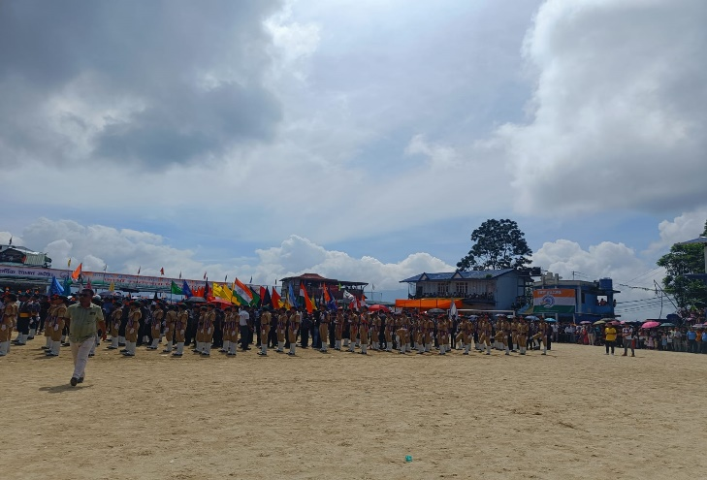PHOTO GALLERY

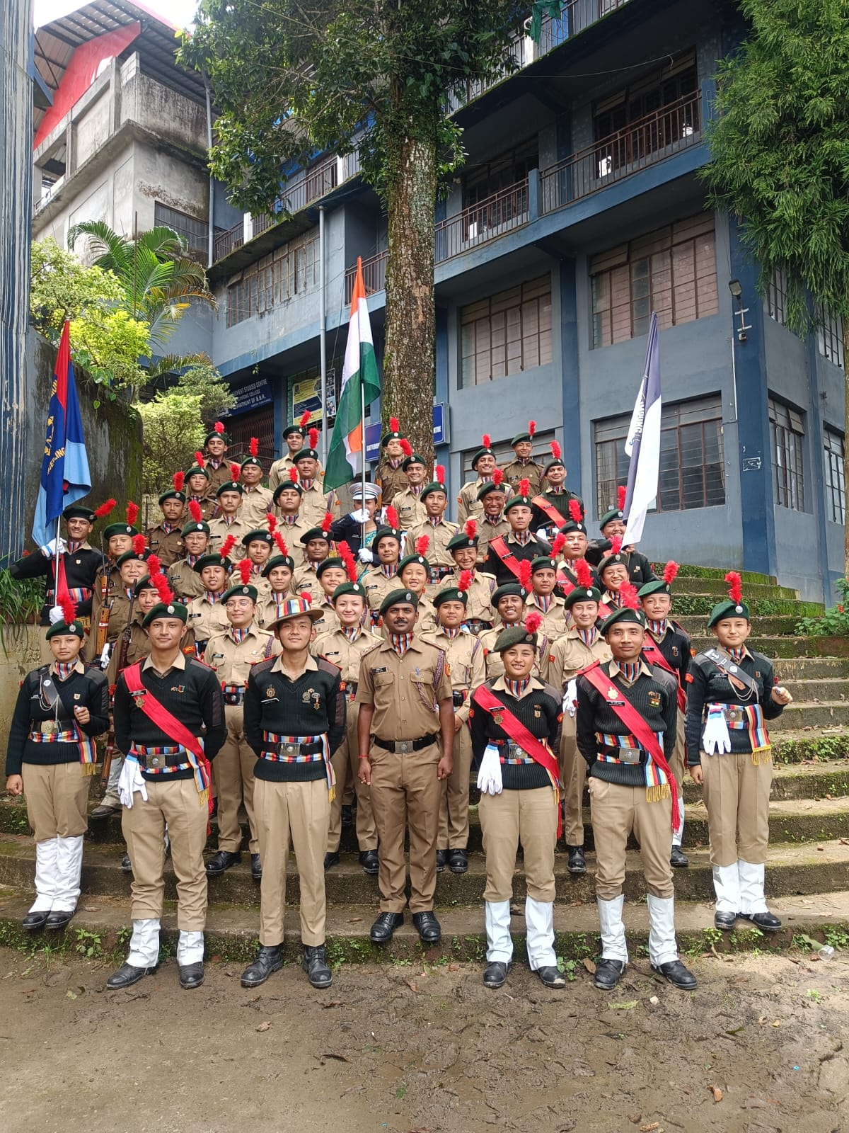



**World Environment Day Celebration – 2022-23**

**Introduction**

World Environment Day, observed globally on June 5th, is an initiative led by the United Nations to raise awareness and prompt action on critical environmental issues. Every year, this day serves as a call to individuals, communities, and governments worldwide to take meaningful steps towards protecting the planet. The Kalimpong College NCC cadets have always been at the forefront of environmental efforts, promoting cleanliness and eco-friendly practices both within their college and in the surrounding community.

In 2023, Kalimpong College NCC, in collaboration with other college organizations, took the initiative to clean and beautify the campus, inspiring students and faculty to join in the effort. This year’s celebration was a powerful example of teamwork, leadership, and dedication to the environment.

**Activities and Participation**

On June 5, 2023, the Kalimpong College NCC cadets organized a cleanliness drive within the college campus, which included cleaning and painting various areas. The initiative not only helped improve the appearance of the college but also set an inspiring example for others to follow. The cadets' hard work and commitment motivated other students to participate in the drive.

Cadets Participated: 52 Cadets

Supervision: Lt. Avijit Mete (ANO)

Collaborating Organizations: Various college organizations joined hands with the NCC to make the event successful.

Refreshments: Provided by the College Authorities to all participants.

**Event Summary**

The event started with a motivational briefing by Lt. Avijit Mete, who emphasized the importance of maintaining cleanliness not just on World Environment Day but as a daily practice. The cadets were divided into teams, each assigned to specific areas of the college campus for cleaning and beautification. Alongside cleaning, cadets also painted parts of the campus, giving it a fresh and vibrant look.



**Impact and Motivation**

The efforts of the NCC cadets had a profound impact on the college community. Seeing the cadets' dedication and hard work, many other students voluntarily joined the drive, contributing to the success of the event. This collaborative spirit created a sense of unity and shared responsibility toward the environment. The initiative also emphasized the importance of maintaining cleanliness not only on special occasions like World Environment Day but as an ongoing commitment.

**Ongoing Efforts**

The Kalimpong College NCC cadets do not limit their efforts to just one day. They regularly engage in cleanliness drives, both within the college and in their localities. The cadets are dedicated to keeping their homes, neighborhoods, and surroundings clean, setting an inspiring example for future generations.

**Conclusion**

The 2023 World Environment Day celebration at Kalimpong College was a remarkable success, thanks to the enthusiasm and commitment of the NCC cadets. Their efforts not only improved the college campus but also inspired others to adopt sustainable practices in their daily lives. The Kalimpong College NCC unit continues to lead by example in promoting environmental responsibility and is dedicated to making the world a greener, cleaner place for future generations.

This report details the key activities and impact of the World Environment Day celebration at Kalimpong College and is ready for submission.

----------------

PHOTO GALLERY

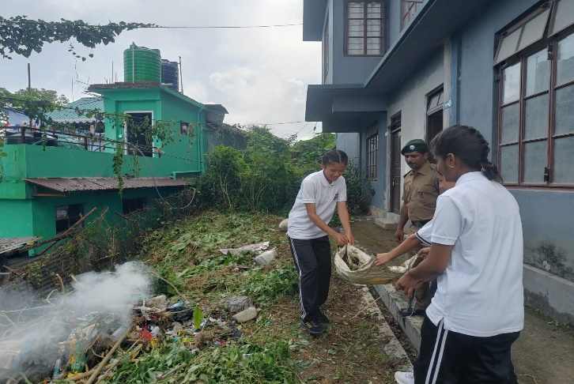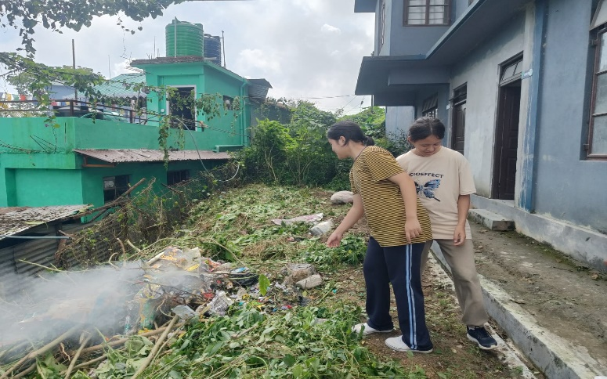

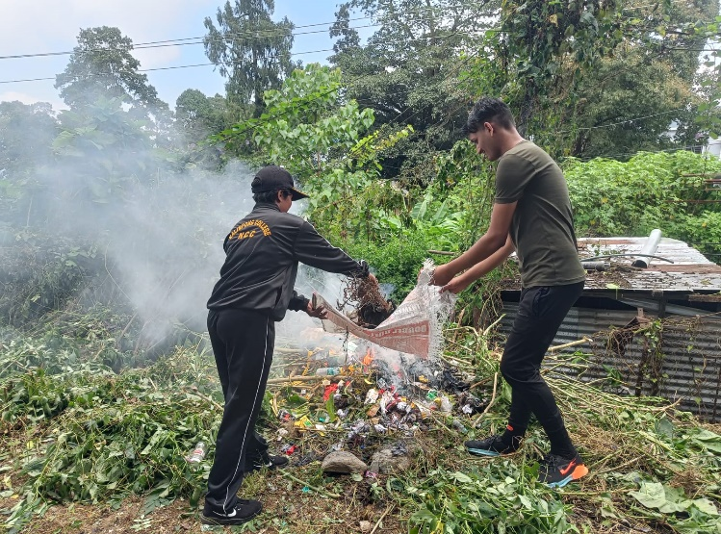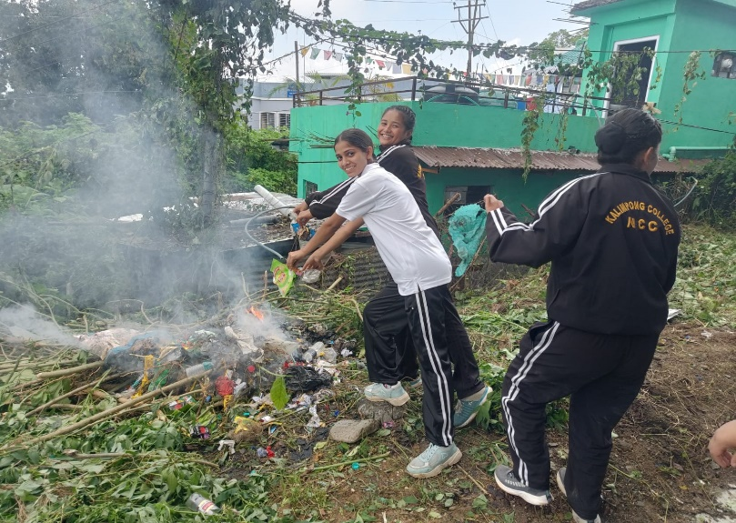



**Significance of International Yoga Day-2022-23**

International Yoga Day, celebrated annually on June 21st, highlights the importance of yoga in promoting physical, mental, and spiritual well-being. Established by the United Nations in 2014, the day emphasizes the global relevance of this ancient practice in fostering harmony between mind, body, and soul.

Yoga, which originated in India over 5,000 years ago, transcends cultural and geographical boundaries, offering a universal path to health and inner peace. On this day, millions of people worldwide participate in yoga sessions, spreading awareness about its benefits. Yoga is widely recognized for reducing stress, improving flexibility, enhancing mindfulness, and combating lifestyle-related diseases.

By observing International Yoga Day, the world collectively acknowledges the power of yoga to address modern challenges such as stress and anxiety, promoting a healthier and more balanced global community.

**Kalimpong College's Yoga Day Celebration**

Each year, Kalimpong College organizes a special Yoga Session on the college campus, where students and teachers actively participate. This event creates a positive environment and fosters a sense of unity and well-being among all participants. The cadets of Kalimpong College NCC also contribute significantly to this event, participating in large numbers under the leadership of Senior Under Officer, Junior Under Officers, and ANO Sir, Lt. Avijit Mete.

This Year’s Celebration:

Date: 21st June

Time: 7:00 AM – 9:00 AM

Total Participants: 36 NCC Cadets

Supervision: Lt. Avijit Mete (ANO)

The NCC cadets played a vital role in organizing the event, assisting with setting up the stage and other preparations. After the session, they helped dismantle and organize the materials, ensuring everything was placed back in order.

This year’s Yoga Day celebration, like every year, concluded with positive energy and a sense of accomplishment. The involvement of Kalimpong College NCC cadets contributed greatly to the event's success, making it a memorable and inspiring experience for all participants.

Submitted by: Kalimpong College NCC Unit.

------------------